Task 1
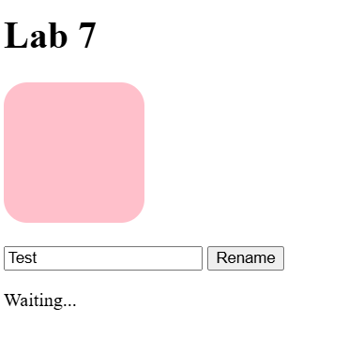
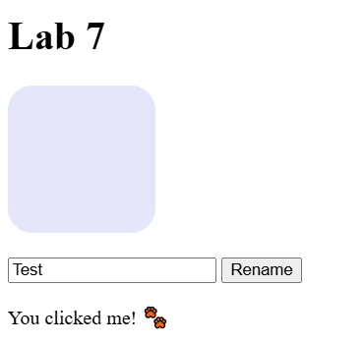
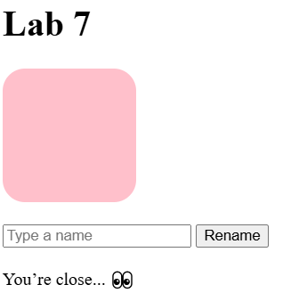
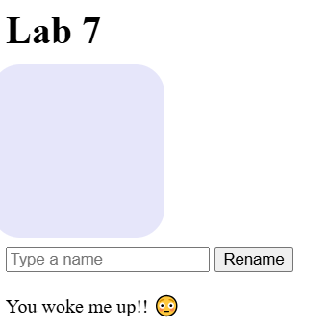
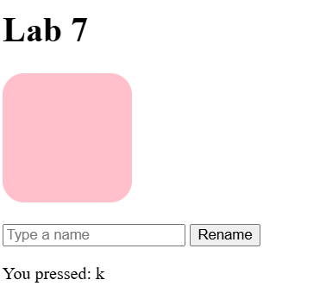
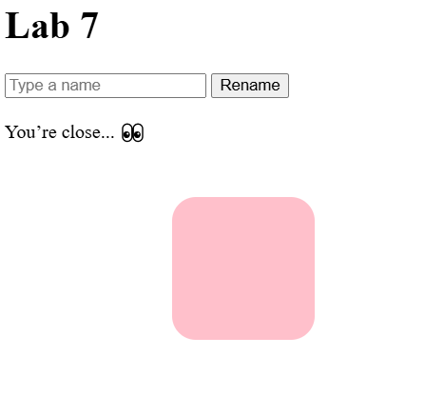

Task 2
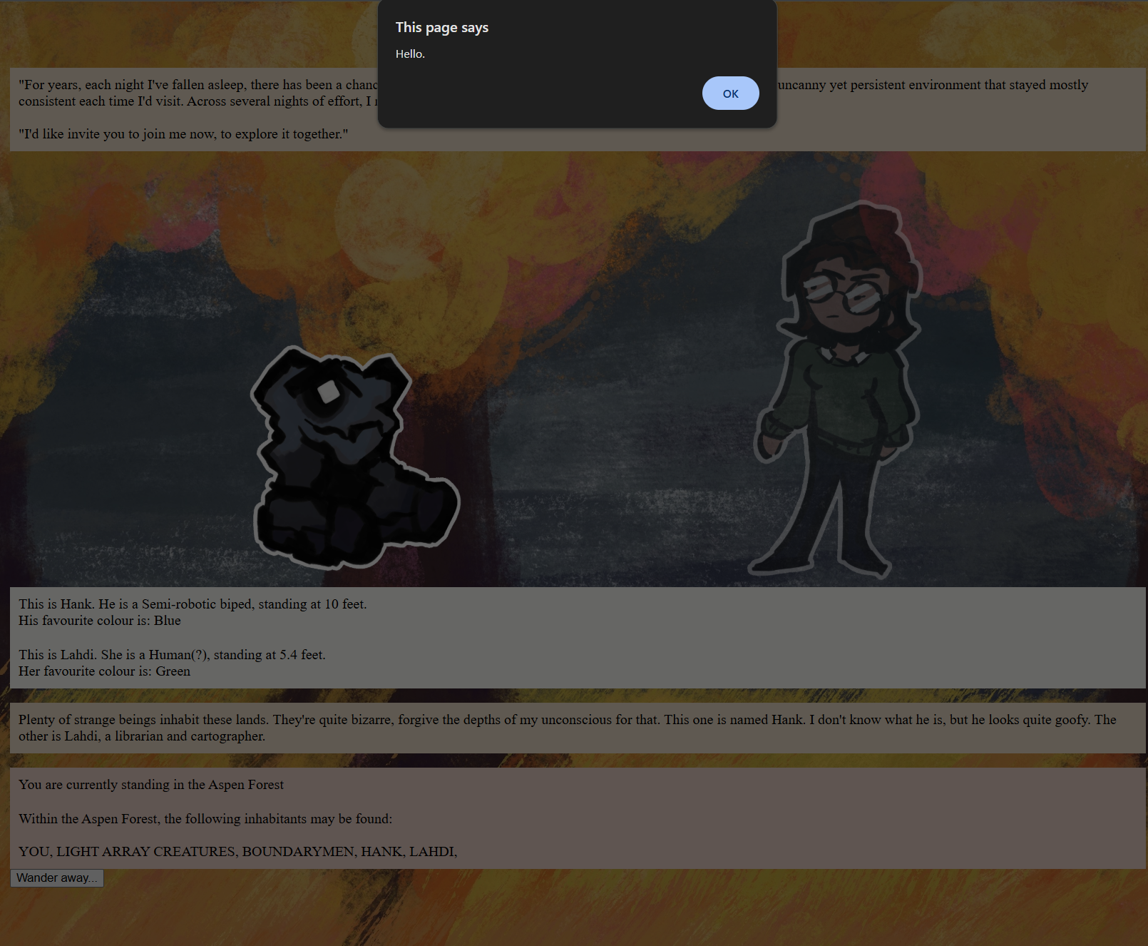
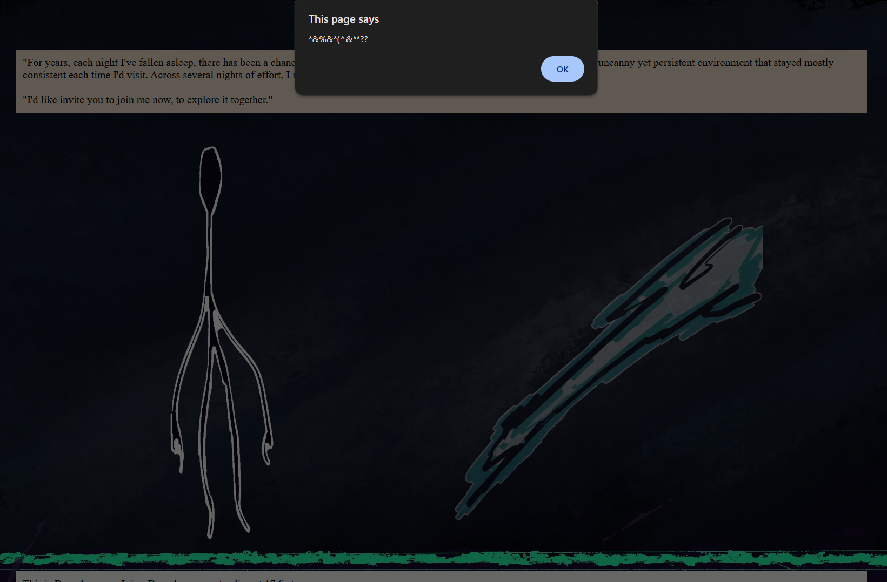
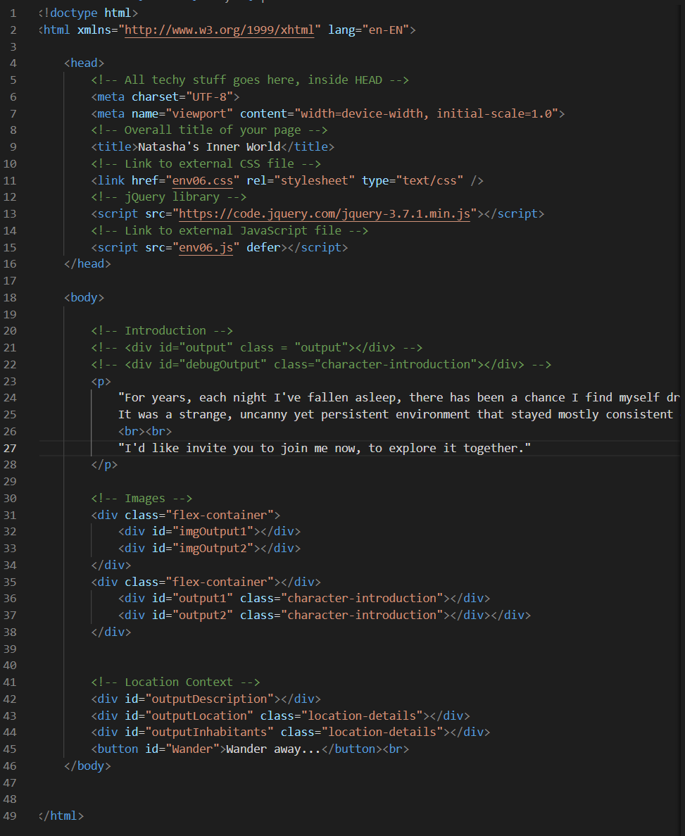
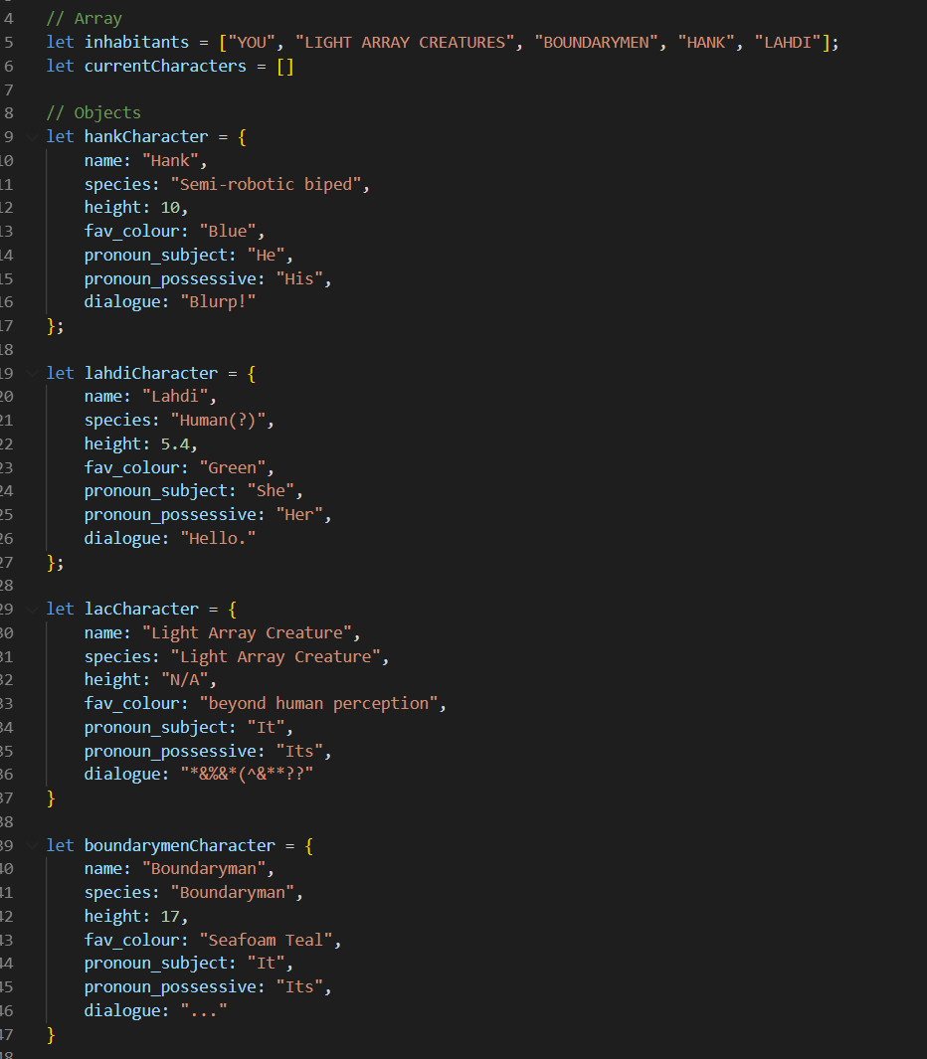
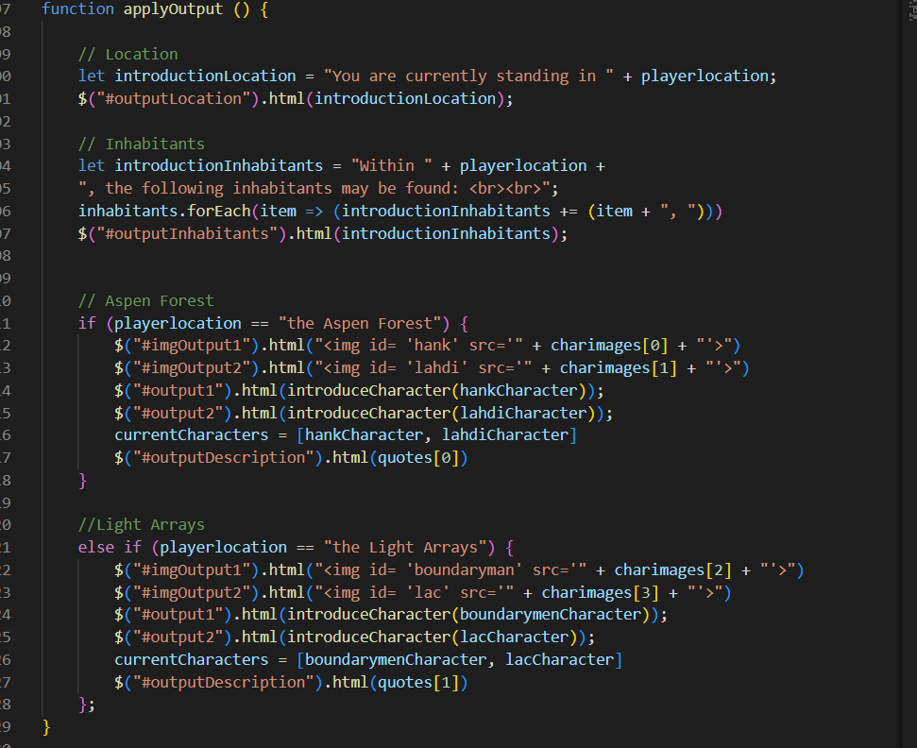
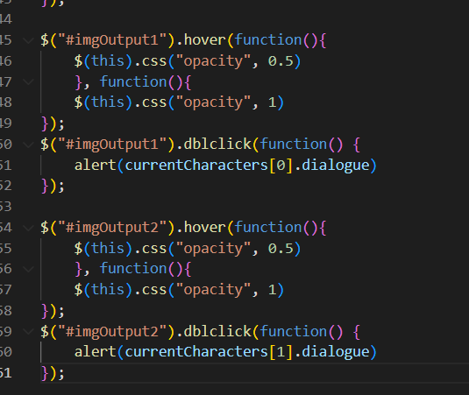
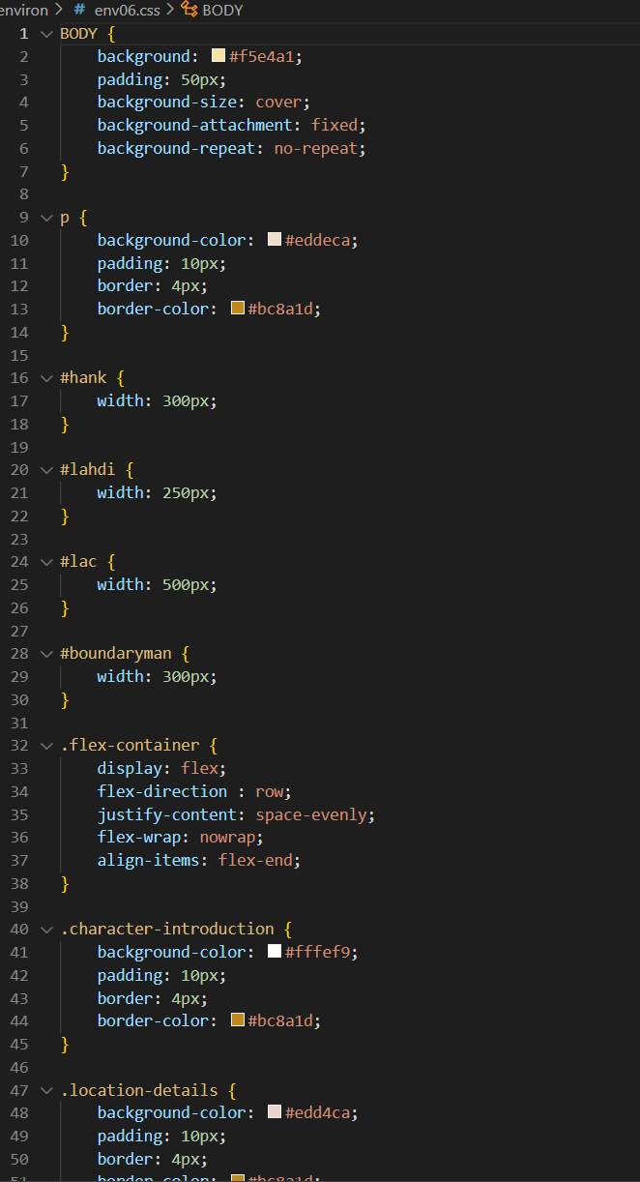

Task 3

https://natashamakani.github.io/ART101New/

Task 4
1.
Like usual, I had no issues with Task 1. I followed the directions, and everything worked!
2.
I wanted to add dialogue, so I figured I could use the alert system and tie it into the dblclick event since that’s not one I’ve used before on the page. I’ll probably refactor it to display elsewhere eventually.
3.
Luna and I sent updates and shared pages as usual. Neither one of us needed the other’s help for this lab- either it’s simple, or we’re both getting better at working with code. I would like to believe the latter!

